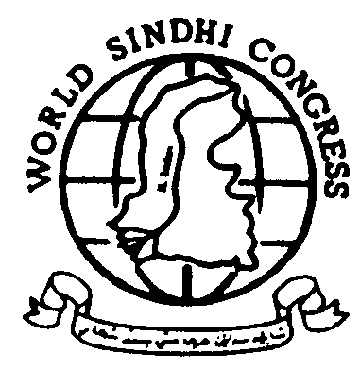WORLD SINDHI CONGRESS
UK: 57 Close Hector, Cardiff CF24 2HL Wales, UK
Tel +44 (292) 0458822 ~ Fax +44 (870) 1226007
USA: 3369 Union Springs Way, Sacramento, CA 95827
Phone +1-916-854-2520 ~ Fax +1-708-585-4284
Email world_sindhi_congress@yahoo.com
URL http://www.worldsindhicongress.org

FOR IMMEDIATE RELEASE
WSC/02/01/1
DR SAFDAR SARKI - CHAIRPERSON
Houston, Texas, USA, March 4th, 2002
WSC Commemorates the Birth Anniversary of Saeen G. M. Syed in Houston
The World Sindhi Congress organized a gathering on March 2nd, 2002 in Houston, Texas (USA) to commemorate the 99th birth anniversary of Saeen G. M. Syed.
Saeen G. M. Syed was a visionary of modern Sindh. He pioneered the Sindhi freedom movement and also served as the chairman of the World Sindhi Congress during 1994-95. Over three decades, Saeen G. M. Syed was repeatedly detained in various Pakistani prisons without trial until his death in 1995. The Amnesty International adopted him as a Prisoner of Conscience. Mr. Syed extensively wrote on Sindhi identity, Sindhi religious thoughts, and political situations in Sindh.
The meeting in Houston was attended by Dr. Safdar Sarki, Chairman WSC, Mr. Umed Ali Laghari, Senior Vice Chairman, WSC, Mr. Suhail Memon, leader of JSQM, and several other local activists from Texas. At the start of the ceremony, these office bearers cut a cake prepared for the birth anniversary.
Mr. Suhail Memon, who is a writer of three books on Syed, said that Saeen G. M. Syed was the one who brought the message of freedom, justice and peace to People of Sindh and other oppressed nations of Pakistan. He said Saeen Syed spent more than thirty years in prison without any trial. Saeen G. M. Syed died in custody at the age of 92. He said that current Pakistani setup does not provide any consolation of Sindhi people. He also appealed to the international community for showing its support to Sindhi people’s struggle for fair rights on Indus River water. He elaborated on the long campaign of JSQM and other parties on environmental rights issues. Several hundreds of activists were assaulted and imprisoned by the authorities during these campaigns.
Mr. U. Laghari paid his tributes to Saeen G. M. Syed. He said that Syed has a special place in the history of Sindhi nation's struggle for freedom. He introduced the objectives and plans of WSC. He said that WSC with its limited resources is working very hard to bring Sindh’s concern at some international forums.
Dr. Sarki, in his keynote speech introduced the life and struggle of Saeen G. M. Syed. He stated that G. M. Syed struggled for the rights of Sindhis throughout his life. He upheld the building of Sindhudesh -a separate homeland for Sindhis - where all Sindhis could live in peace under a secular democratic system. He regarded Sindhis dispersed all over the world as an important part of the Sindhi nation. He considered the freedom of Sindh as a lasting solution for peace in South Asia. He further said, WSC would keep advocating his message for freedom.
The meeting passed several resolutions condemning the brutal murder of American Journalist Daniel Pearl. They offered their condolences to Mr. Pearl’s family and to the American people. They also demanded from Pakistani authorities the release of JSQM leaders, Mr. Bashir Khan, Niaz Kalani, cancellation of the construction of Thal Canal and the thorough investigations of the death of Ms. Uma Devi, a Sindhi Hindu college student, and the murder of Mr. Suddham Chawla, a Sindhi Hindu Human Rights leader.

